HTTP Requests & Responses

🧾 What Are HTTP Requests & Responses?
# Source: AI Source: Provided by: [Data Path: Persons Table -> ID Column: 1, Name_En Column: Motasem Essam] -> From: [ChatGPT] on [2/12/2026]
They are the main way of communication between a client (browser/app) and a server on the web.
👉 Everything you do online (open a page, login, send data) uses this cycle.

✅ Simple Definition:
# Source: AI Source: Provided by: [Data Path: Persons Table -> ID Column: 1, Name_En Column: Motasem Essam] -> From: [ChatGPT] on [2/12/2026]
● HTTP Request → message sent by the client to ask for data or action
● HTTP Response → message sent by the server with the result

🧠 Real-Life Analogy:
# Source: AI Source: Provided by: [Data Path: Persons Table -> ID Column: 1, Name_En Column: Motasem Essam] -> From: [ChatGPT] on [2/12/2026]
Think of it like a restaurant 🍽️:
● You (client) → place an order (request)
● Waiter → takes your order
● Kitchen → prepares the food
● Waiter → brings your food (response)

🔁 How It Works (Step-by-Step)
# Source: AI Source: Provided by: [Data Path: Persons Table -> ID Column: 1, Name_En Column: Motasem Essam] -> From: [ChatGPT] on [2/12/2026]
- 👤 You open a website or click a button
- 🌐 Browser sends an HTTP Request
- ⚙️ Server receives the request
- 🧠 Server processes it
- 📥 Server sends back an HTTP Response
- 🖥️ Browser displays the result

📤 HTTP Request Structure
# Source: AI Source: Provided by: [Data Path: Persons Table -> ID Column: 1, Name_En Column: Motasem Essam] -> From: [ChatGPT] on [2/12/2026]
A request contains:
● Method (GET, POST, etc.)
● URL (endpoint)
● Headers (metadata)
● Body (optional data)

📥 HTTP Response Structure
# Source: AI Source: Provided by: [Data Path: Persons Table -> ID Column: 1, Name_En Column: Motasem Essam] -> From: [ChatGPT] on [2/12/2026]
A response contains:
● Status code (200, 404, 500…)
● Headers
● Body (data like HTML, JSON)

⚙️ Example of HTTP Request
# Source: AI Source: Provided by: [Data Path: Persons Table -> ID Column: 1, Name_En Column: Motasem Essam] -> From: [ChatGPT] on [2/12/2026]
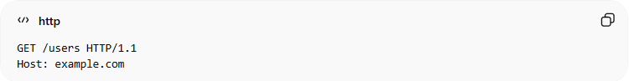
GET /users HTTP/1.1
Host: example.com
● GET → request method
● /users → endpoint
● Host → server address

📥 Example of HTTP Response
# Source: AI Source: Provided by: [Data Path: Persons Table -> ID Column: 1, Name_En Column: Motasem Essam] -> From: [ChatGPT] on [2/12/2026]
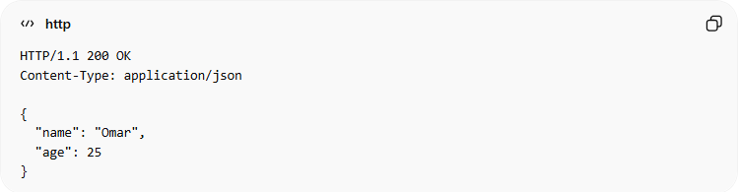
HTTP/1.1 200 OK
Content-Type: application/json

{
"name": "Omar",
"age": 25
}
● 200 → success
● JSON data returned

📊 Common HTTP Status Codes
# Source: AI Source: Provided by: [Data Path: Persons Table -> ID Column: 1, Name_En Column: Motasem Essam] -> From: [ChatGPT] on [2/12/2026]
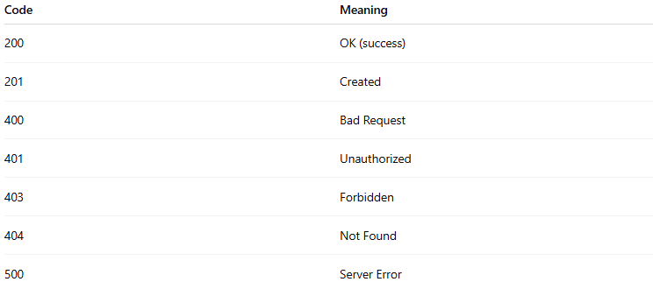
Code | Meaning
200 | OK (success)
201 | Created
400 | Bad Request
401 | Unauthorized
403 | Forbidden
404 | Not Found
500 | Server Error

🔗 Relation to Other Topics
# Source: AI Source: Provided by: [Data Path: Persons Table -> ID Column: 1, Name_En Column: Motasem Essam] -> From: [ChatGPT] on [2/12/2026]
● HTTP Request → sends data to API
● HTTP Response → returns result
● Headers → include tokens (authentication)
● Data Formats → JSON, XML in body

💻 Simple PHP Example (Response)
# Source: AI Source: Provided by: [Data Path: Persons Table -> ID Column: 1, Name_En Column: Motasem Essam] -> From: [ChatGPT] on [2/12/2026]
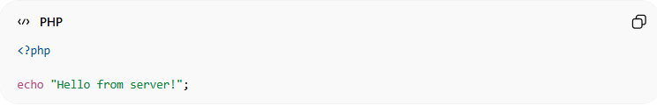
<?php

echo "Hello from server!";
● PHP generates a response
● Server sends it back to browser

🎯 Key Idea
# Source: AI Source: Provided by: [Data Path: Persons Table -> ID Column: 1, Name_En Column: Motasem Essam] -> From: [ChatGPT] on [2/12/2026]
👉 Request = Ask
👉 Response = Answer

🎓 Final Mental Model
# Source: AI Source: Provided by: [Data Path: Persons Table -> ID Column: 1, Name_En Column: Motasem Essam] -> From: [ChatGPT] on [2/12/2026]
● Client always initiates (request)
● Server always responds
● This cycle is the foundation of the web

